

**Video Training Document**

Contents:

I. Setup github account and push data: 3

II. Introduction of Video 7

III. Display Resolution 8

IV. Frame per second 9

V. Bit-depth 9

VI. Video Container 12

VII. Codecs 12

VIII. Video File Format 14

IX. Group Of Pictures 14

X. Chroma Subsampling 15

XI. Video Streaming 20

XII. Video Encoding 20

XIII. Video Decoding 20

XIV. Image Compression 20

XV. References 21

# Setup github account and push data:

1. For create github account visit <https://github.com/>
2. Bellow view will open, if already have account or have to create new account base on that select sign in or sign up respectively.

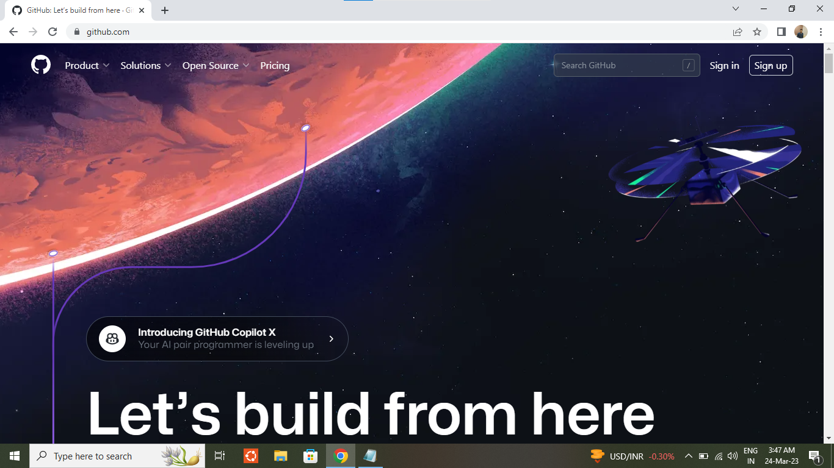

1. For create new account following details have to fill up.

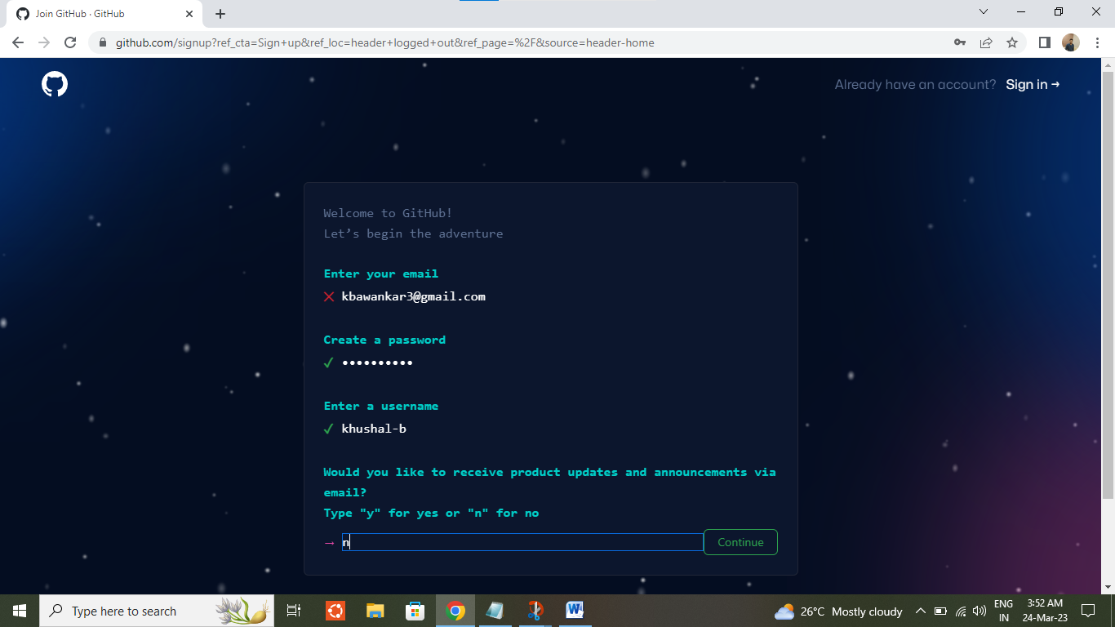

1. Click on solve puzzle for start verification.

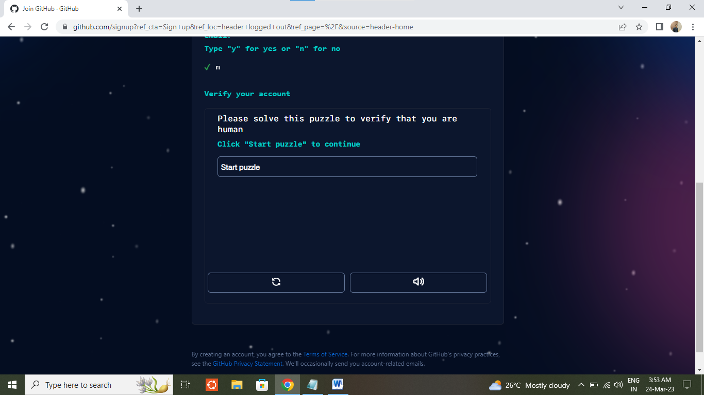

1. Once done above step click on create account. Account will be create.

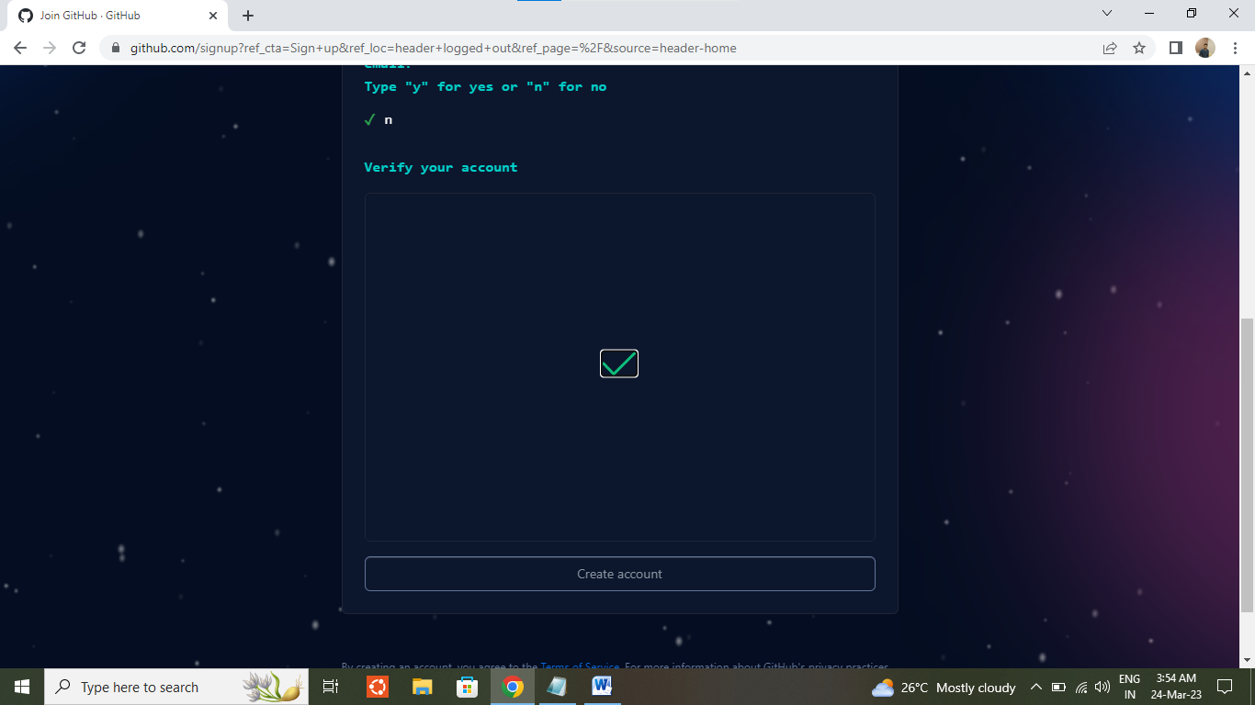

1. After login to the account below interface will be come out. For create repository select below option.

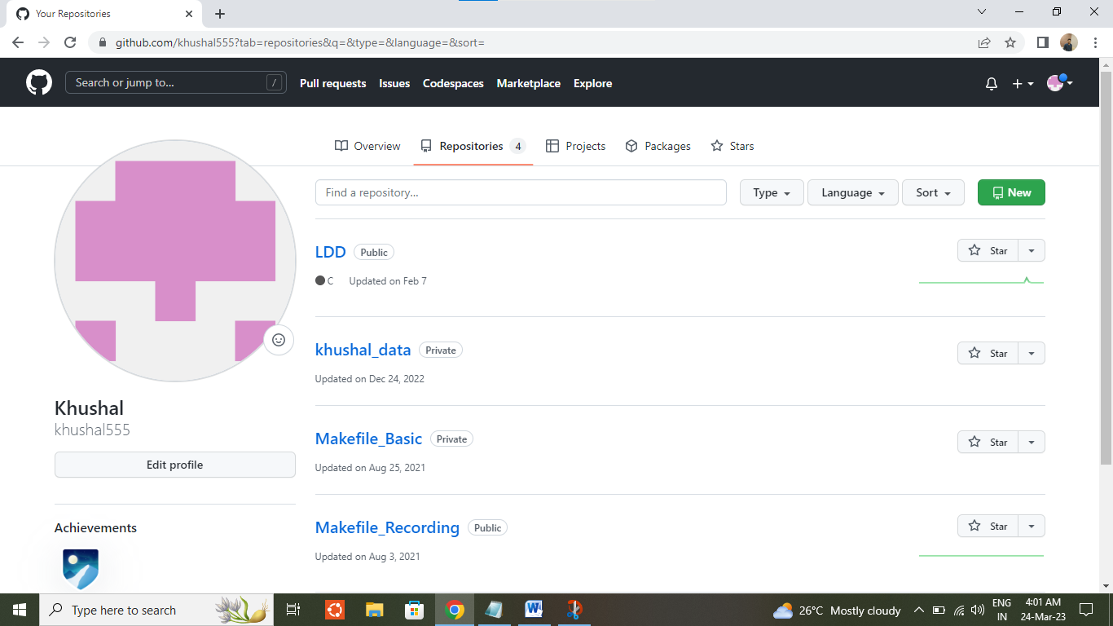

**1**

**2**

1. Enter repo name, select privacy as public or private as per requirement. Come at the end and select create repository.

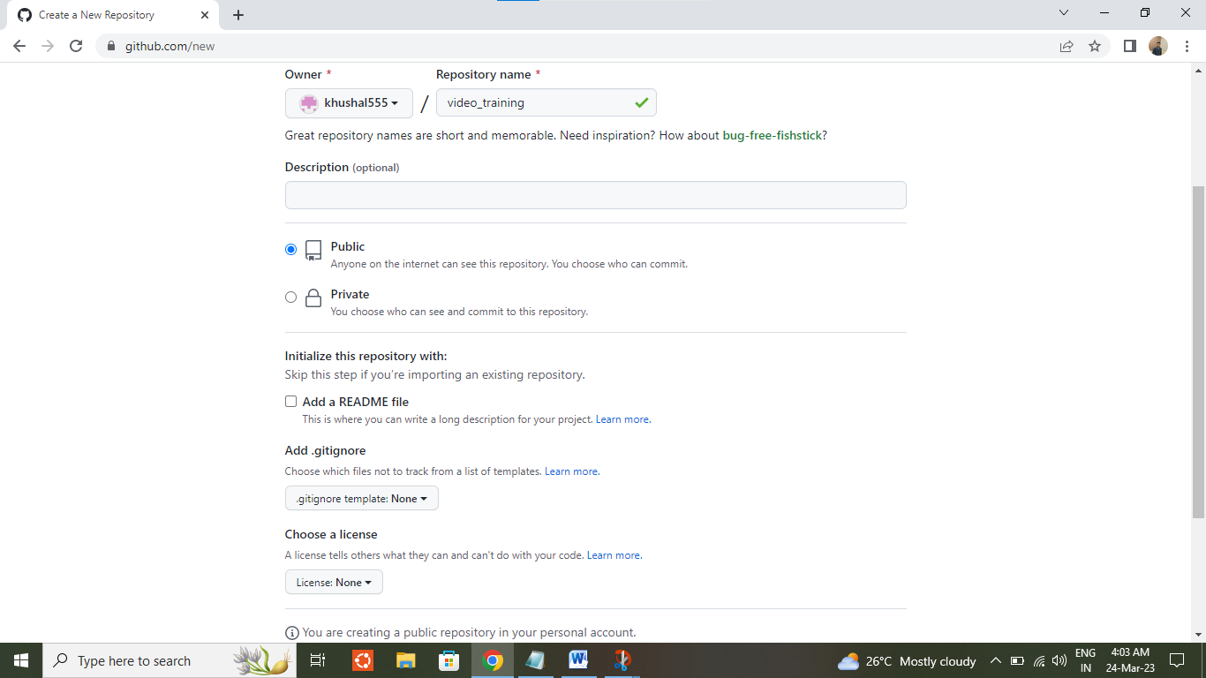

SSH url will be used for push or pull data from github account.

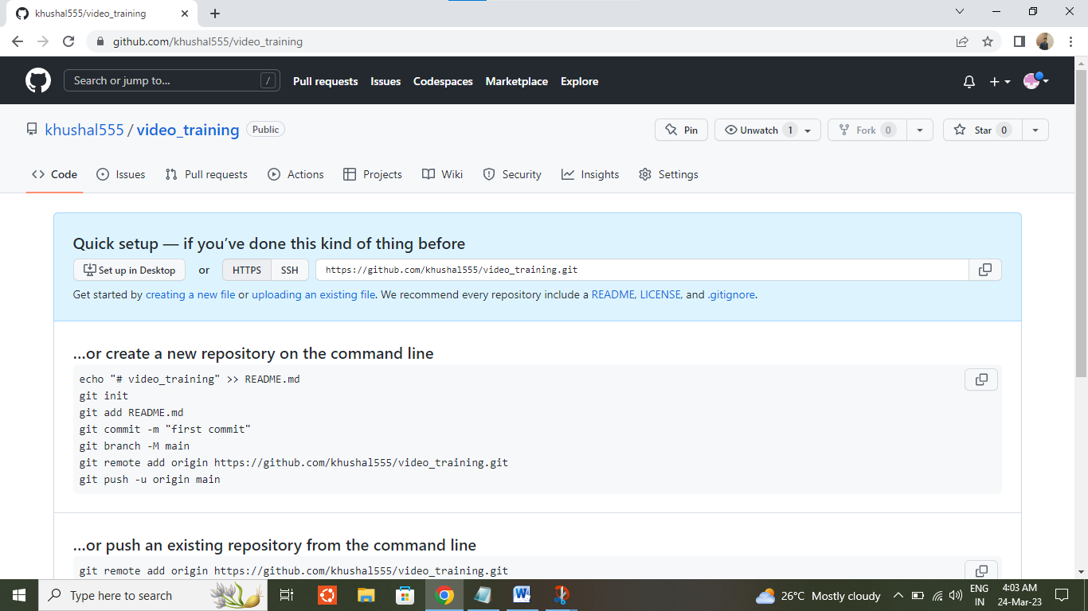

1. After add and commit the required file which has to push on github just add ssh by “git remote add” command. And then committed data can be push by “git push” command.

While push any data username and password, have to enter. This password will be a token number and can be generate by following <https://docs.github.com/en/authentication/keeping-your-account-and-data-secure/creating-a-personal-access-token> this page.

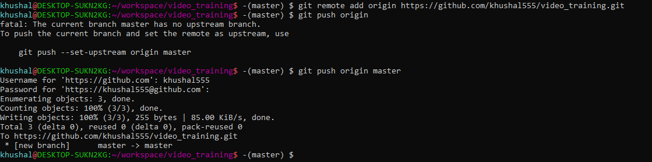

# Introduction of Video

Recording of an image or moving images is known as video.

Video is used to generate a steady source of still pictures as it is a series of electronic signals, which simulate movement.

It’s a technology for electronic capture, storage and transmission of images and motion picture.

Light waves of object passes through lens, that light converted into electrical signals using Charge Coupled Device (CCD). In cameras three CCD use for three different hue (R, G, and B).

Video follow three standards:

1. Luminance: Brightness of pixel.
2. Chrominance: Color information
3. Synchronization: Series of electronic pulses that control by time of each frame of video.

Video is categorized in two types.

1. Analog Video
2. Digital Video

|  |  |  |
| --- | --- | --- |
| Sr. | Analog Video | Digital Video |
| 1 | Digital signals are used for transition of data. At the end when its combine its known as composite video. | It is an electronic representation of moving visual images in the form of encoded digital data. |
| 2 | Have continues electrical signal. | Non-continues electrical signal. |
| 3 | Use many line per frames. | It has different frames. (P, B and I frame). |
| 4 | It’s a continues waveform | Composition of discrete bit |
| 5 | Analog video continues signal to capture footage on magnetic tape. | Digital video is made up of composition of bits, which can read by the processor. |
| 6 | Have varying signal. | Have square wave or clock signal. |
| 7 | Max value will be positive and min value will be negative. | Max value will be 5 volts and min value will be 0 volt. |
| 8 | Use mainly for audio and video transmission. | Use to suit for digital electronic devices. |
| 9 | Ex. Magnetic Tape | Ex: Mobile, PC, DVD. |

Analog video is prepared for digital transmission:

Sampling code -> Digitizing Modulation -> Source Encoding -> Multiplexing -> Channel

Sampling code = Image get sampled

Digitizing = Convert samples into digital data

Encoding = Convert to particular format

Multiplexing = Amplify data

Channel = Use for Transition part

Digital video follow progressive scan by Video Capture Card. This scan draws odd/even lines simultaneously.

NTSC, PAL, SECAM are analog video format use for broadcasting.

**Progressive Video:**Video sources that are listed with the letter **p** are called progressive scan signals. Examples of this would be 480p, 720p or 1080p. Progressive scan video content displays both the even and odd scan lines (the entire video frame) on the TV at the same time. A High Speed HDMI cable is required to transmit a video signal in 1080p.

**Interlaced Video:**  Video sources that are listed with the letter **i** are called interlaced. An example of this would be 480i or 1080i. Interlaced video displays even and odd scan lines as separate fields. The even scan lines are drawn on the screen, then the odd scan lines are drawn on the screen. Two of these even and odd scan line fields make up one video frame.

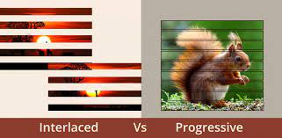

# Display Resolution

A computer screen uses millions of pixels to display images. These pixels are arranged in a grid horizontally and vertically. The number of pixels horizontally and vertically is shown as the screen resolution.

Screen resolution is typically written as 1024 x 768. This means that the screen has 1024 pixels horizontally and 768 pixels vertically.

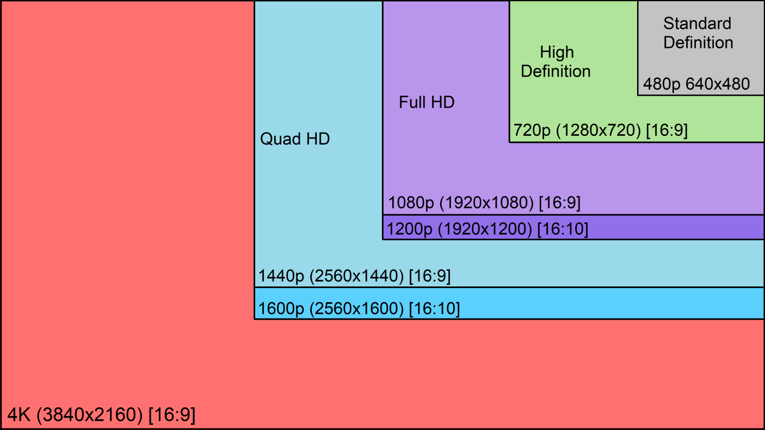

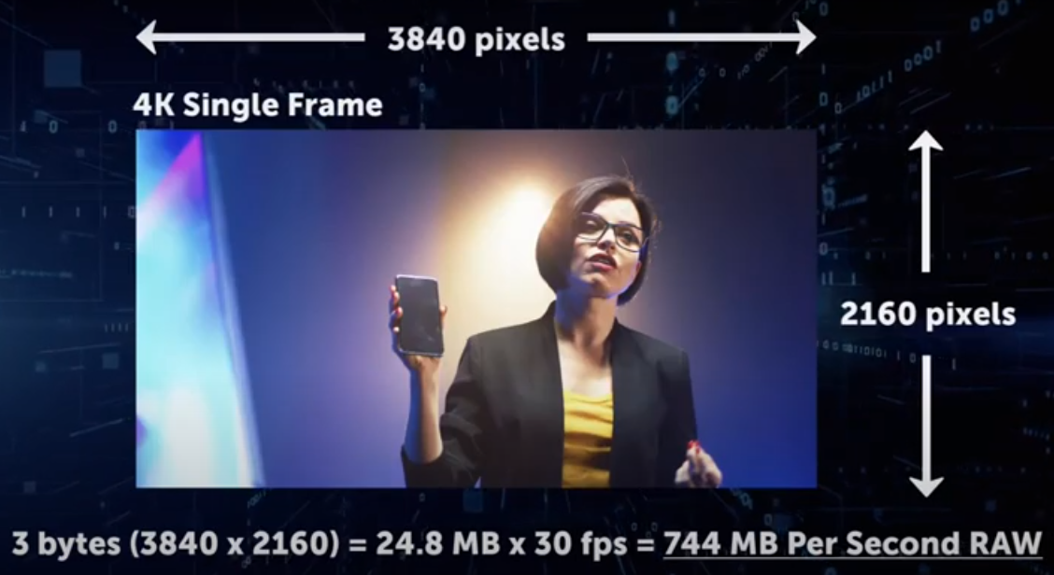

# Frame per second

The number of images consecutively displayed each second.24 FPS is the normal frame rate in video.

60 FPS and 120 FPS makes video slow and slow.

# Bit-depth

Bit depth refers to the color information stored in an image. The higher the bit depth of an image, the more colors it can store. The simplest image, a 1 bit image, can only show two colors, black and white. That is because the 1 bit can only store one of two values, 0 (white) and 1 (black). An 8 bit image can store 256 possible colors, while a 24 bit image can display over 16 million colors. As the bit depth increases, the file size of the image also increases because more color information has to be stored for each pixel in the image.

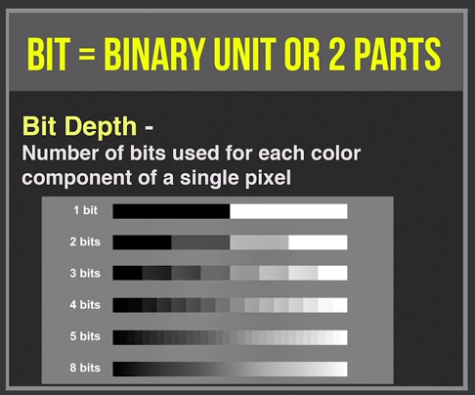

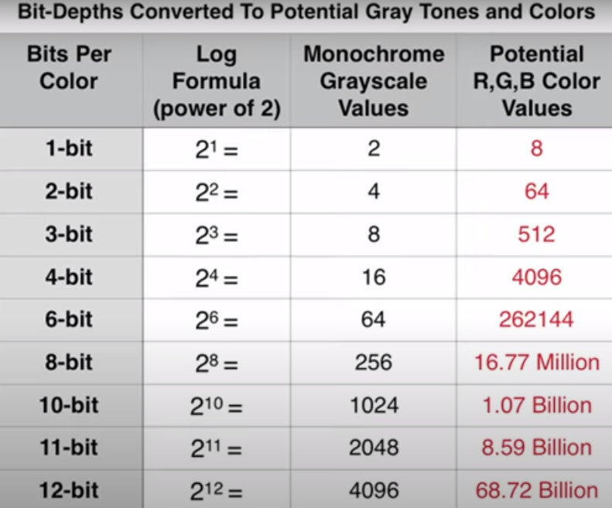

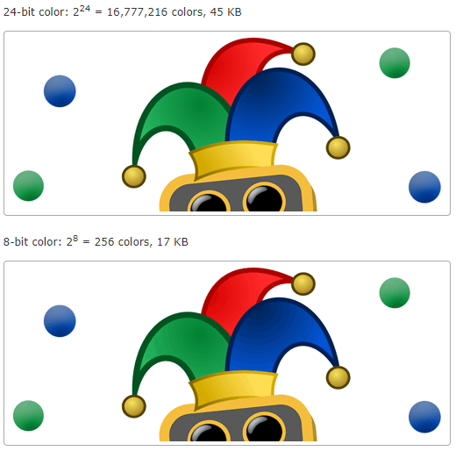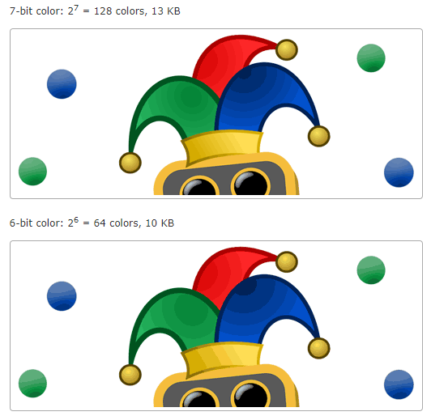

# Video Container

The file extension is the representation of container.

Container consists of information like:

Video stream = Video frames which will visible on screen.

Audio Stream = Audio which will play while play video frames.

Meta data = Data about video and audio like bitrate, resolution, device, etc.

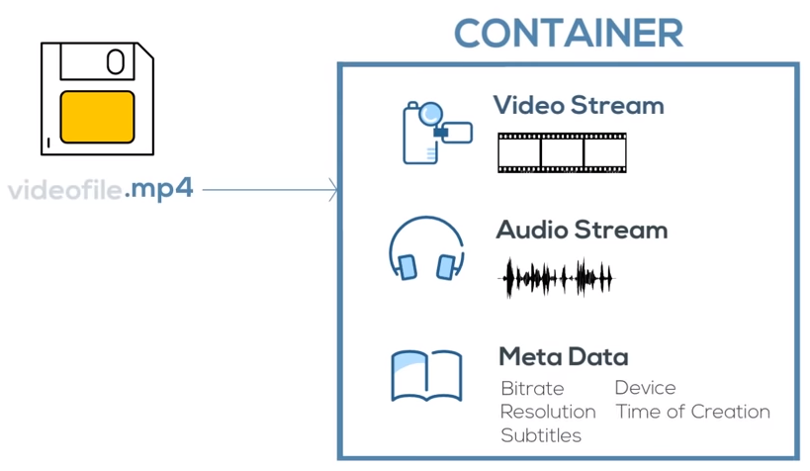

# Codecs

Most important aspect in the Meta data is like **Codecs**.

Codec = Coder Decoder

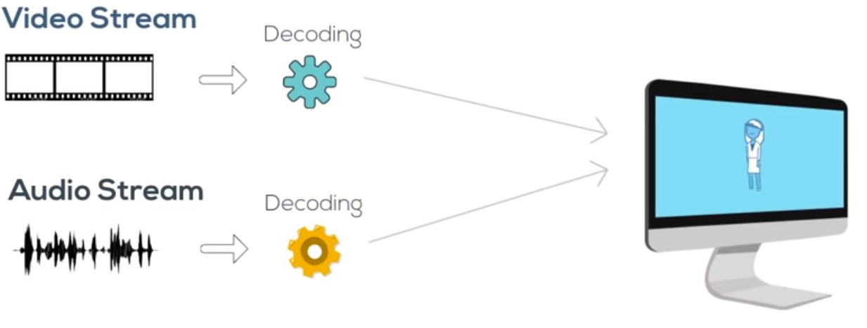

Most common Video Codecs:

1. AVC (Advance Video Coding) / H.264:

* Most widely supportable codec.
* Better bit rate.

1. HEVC (High Efficiency Video Coding) / H.265:

* Compression rate is double than AVC.
* Half the bitrate of AVC.
* Encoded file will be 50% smaller than the file encoded with AVC.
* Good for high resolution video and live streaming.
* But it triples the resources requirement, its drawback.
* Hence not widely use.

1. VP9 – Develop by google:

* Open source.
* Good for high resolution video and live streaming.
* More difficult to encode.
* Not widely use.

1. VP9 vs HEVC:

* VP9 = More consistent and reliable.
* HEVC = Better image quality.

Most common Audio Codecs:

1. MP3:

* Most popular.
* Save space without noticeable audio quality loss.
* 128 kbps audio sounds like original CD but its only the 9% of original audio.
* Limited functionality for videos.

1. AAC (Advanced Audio Coding):

* Widely supported.
* More efficient than MP3. Have better bit rate.
* Limit on Audio channels.

1. AC – 3 (Dolby Digital Audio Codec 3):

Provide surround sound setting.

Have 4 layer audio channels.

Very limited device support.

# Video File Format

Video format is standardized set of rules for strong containers codecs, meta data and folder structure.

Most famous video format:

1. **MP4 (MPEG-4 part 14)**

* part 14 = mp4 container
* part 12 = ISO base media file use for streaming
* part 10 = Codec
* Adaptive Bitrate Segmentation:

As per internet speed video quality will adjust like for slow internet 340P, Medium internet 480P for fast internet 1080P

1. **HLS (HTTP Live Stream):**

HLS support on all kind of platform.

It use .m3u8 (manifest). m3u8 keep all container data together.

1. **MPEG-DASH (Dynamic Adaptive Streaming over HTTP)**

Open source.

International standard for adaptive streaming.

# Group Of Pictures

GOP or “Group of Pictures” is a term that refers to the video structure representing how digital video is grouped.

When a video is encoded to be viewed on television or by any streaming platform, it’s important that it is compressed. In order to more easily transmit digital media, video compression is used to turn large raw video files into smaller video files that can transmit more easily over limited bandwidth. Video compression works by locating and reducing redundancies within an image or a sequence of images. A video is composed of a sequence of frames displayed at a given frequency.

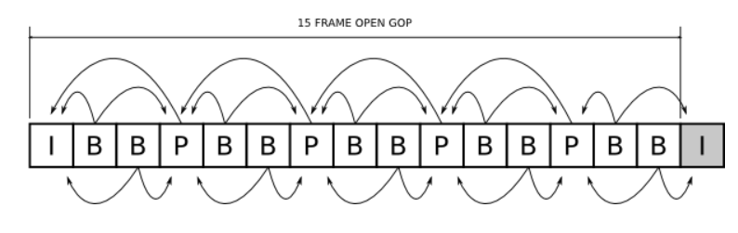

# Chroma Subsampling

It divides the image into pixel block. Or we can say it works only on pixel block for increase or decrease the quality of color i.e. quality of image.  
Chroma = color, Luma = brightness

* Chroma subsampling use:

4:4:4, 4:2:2, 4:2:0

**First four indicates pixel number of blocks as 4**

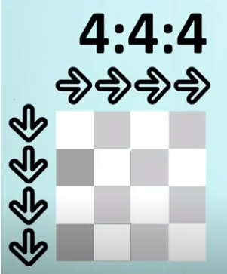

Second four indicates how many blocks have to use for 4 individual and unique colors in 1st row.

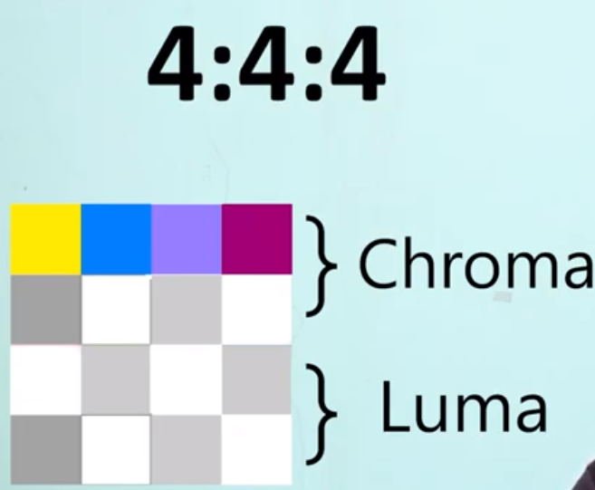

Third 4 indicates, how many blocks have to use for 4 individual and unique colors in 2nd row.

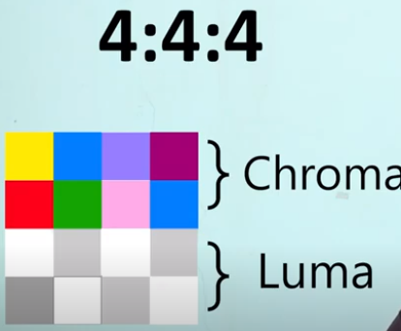

Chroma

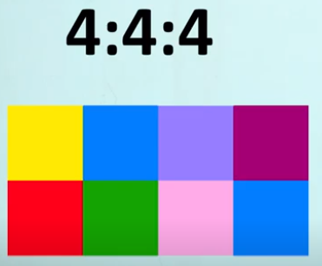

In above part we did not change or modified anything. Hence its loss less compression, due to that we will get 100% clarity.

Chroma + Luma

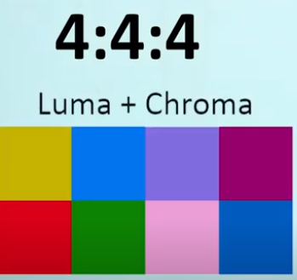

**4:2:2 (10 bit)**

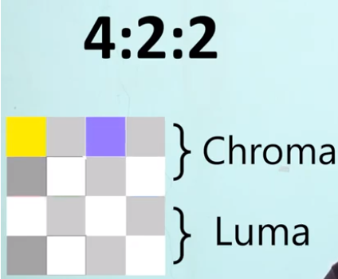

Here first 4 indicate number of rows and column, second 2 indicate only two colors in first row. That means neighboring pixel of same row have to share that color

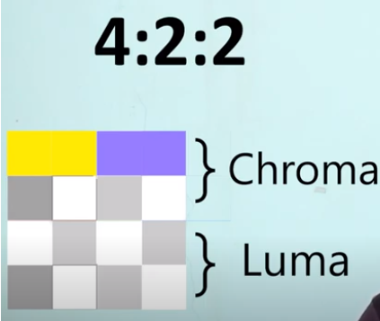

Same with third digit 2,   
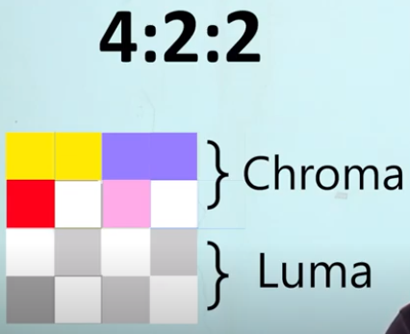

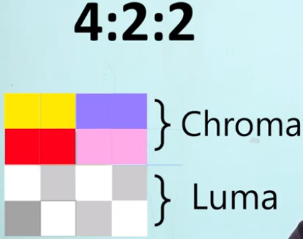

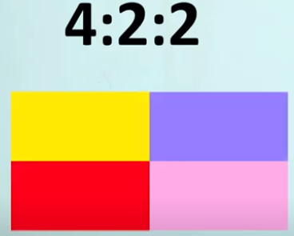

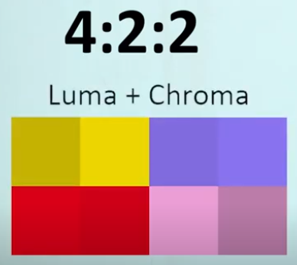

In this method modification and change happened, Hence it’s consider as a lessee compression. Means we are going to miss some pixel blocks and color.

**4:2:0 (8bit)**

Similar to above two methods.

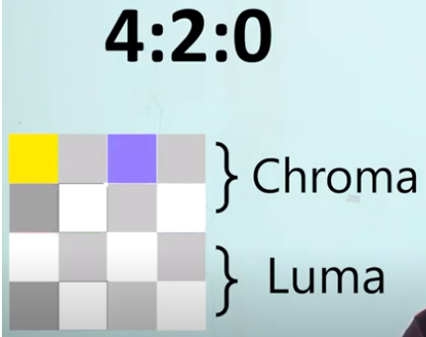

Here third data filed is zero hence first row have to share its color with second row.

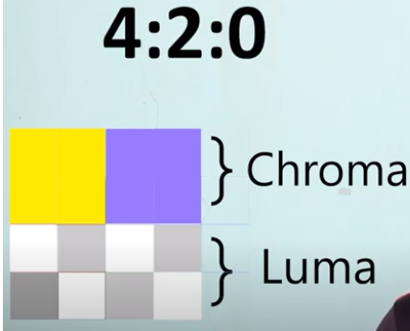

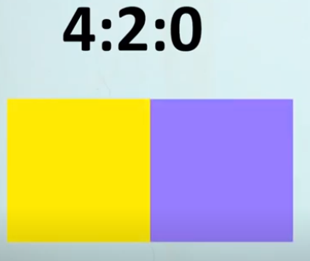

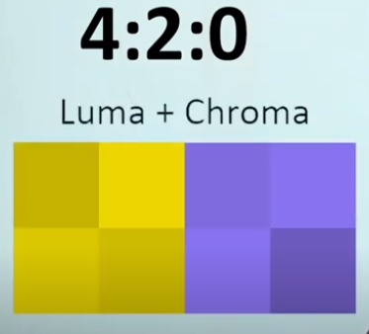

In this method modification and change happened, Hence it’s consider as a lessee compression. Means we are going to miss some pixel blocks and color.

4:4:4:4

This sampling use in .m4v format. This use for make transparent background video. (like PNG images)

# Video Streaming

A continues transmission of audio and video from server to client.

In server data preset in compressed form. Video send from server to client when user want to see any video, like YouTube. When video reach to the client for watch the video that video decompressed using video player.

**Advantages**:

* Allowing users to watch without needing to download it first.
* Providing high resolution, sometimes till 4K.
* Affordability, ranging from free services to subscription services even cheaper than cable.
* A variety of content. Like vlog, tutorials, gaming video, etc.

**Challenges:**

* Internet connection.
* Copyright issues.
* Slower performing client devices.

# Video Encoding

It’s a process to convert raw video signal from camera to compressed digital format for efficient delivery across the internet.

Encoder can be integrated in camera or it can be software in mobile or computer. Encoder use as a studio tool to apply codec compression. This process have audio and video encoding.

# Video Decoding

Its takes the encoded compressed video as input perform decoding operation and gives decoded video as the video can display on screen in respective resolution. Decoder can be software in laptop or mobile, can be set of box use for TV, etc.

# Image Compression

Generally an image is represented as a matrix. Which contain pixel intensity values. Larger number shows a brighter pixel and smaller value represents the darker pixel.

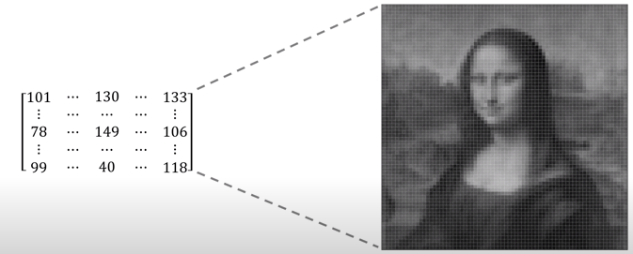

Color images have different color channel for different component like Red, green and blue.

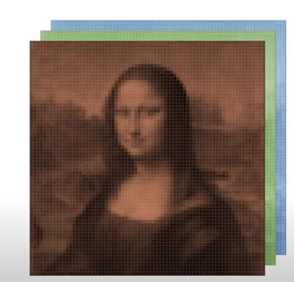

If we have 12 MPx image so it means in each channel 12MPx data entries will be there. So for Red, green and blue for this 3 channels 36MPx values will be there.

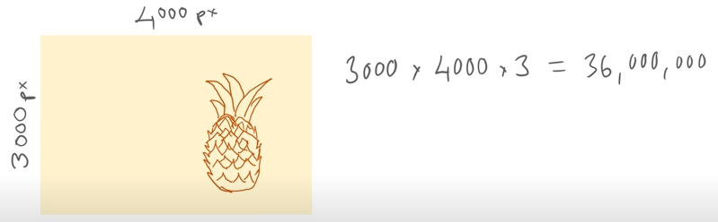

So for this around 36 MB file will required.

For save the memory space image compression is required.

**JPEG** is the most common compression method.

In JPEG it remove some information from image for reduce the file size.

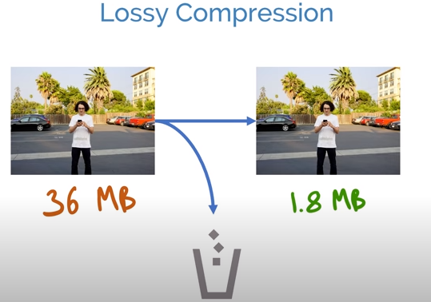

Removing unwanted data for compression is possible by removing unwanted data and that possible by below way:

**Color Space Conversion:**

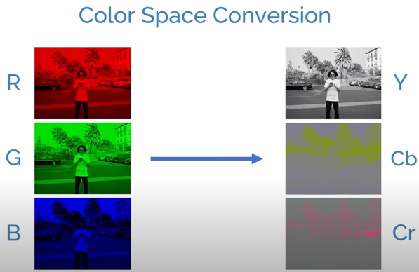

For three different channels we have three different frames. On right side 1st channel is for **Light intensity**. Other two channels represent colors.

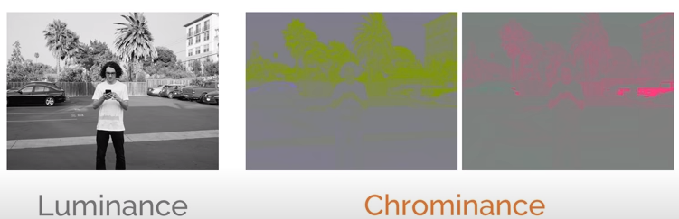

This provides separation of luminance from the chrominance component. If we down sampling the chrominance then even though human eyes can see almost same quality image. This property is known as Chroma subsampling. Its tends to reduce file size and hence it use in many image and video processing pipeline.

Another human eye related this is if we have detailing of small object in image then that cannot be observed by human eyes.

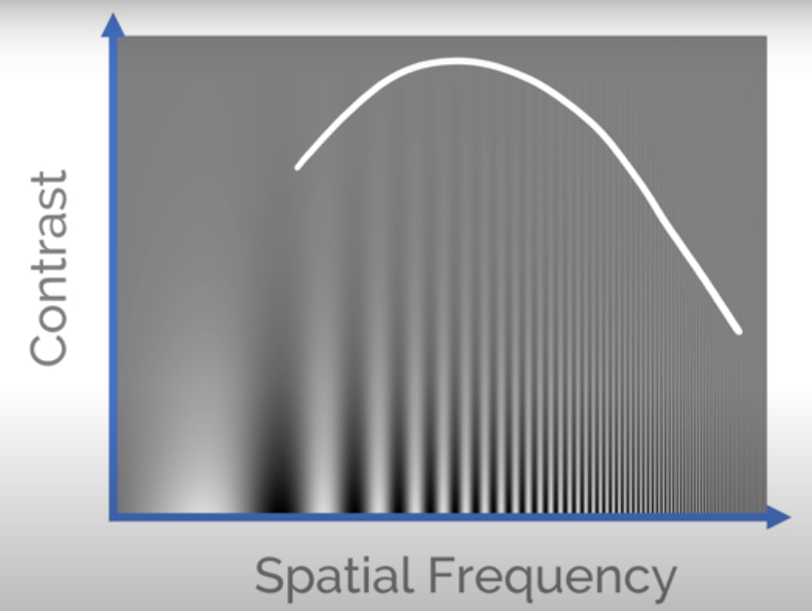

Contrast goes on decreasing from bottom to top, and spatial frequency goes on decreasing from left to right. Its visible till the white color marked curve. The area which is not showing any spatial frequency, i.e. above white curve there compreson can done very easily and can remove thin spatial frequency line so that data can be save.

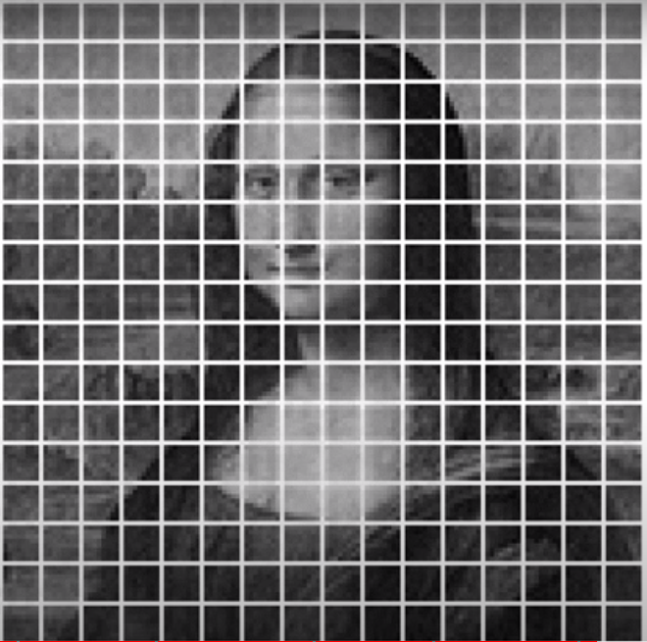

JPEG do that compression by dividing image in 8*8 block and cotising them in frequency domain representation. This is done by 8*8 blocks i.e 64 block of patterns as below.

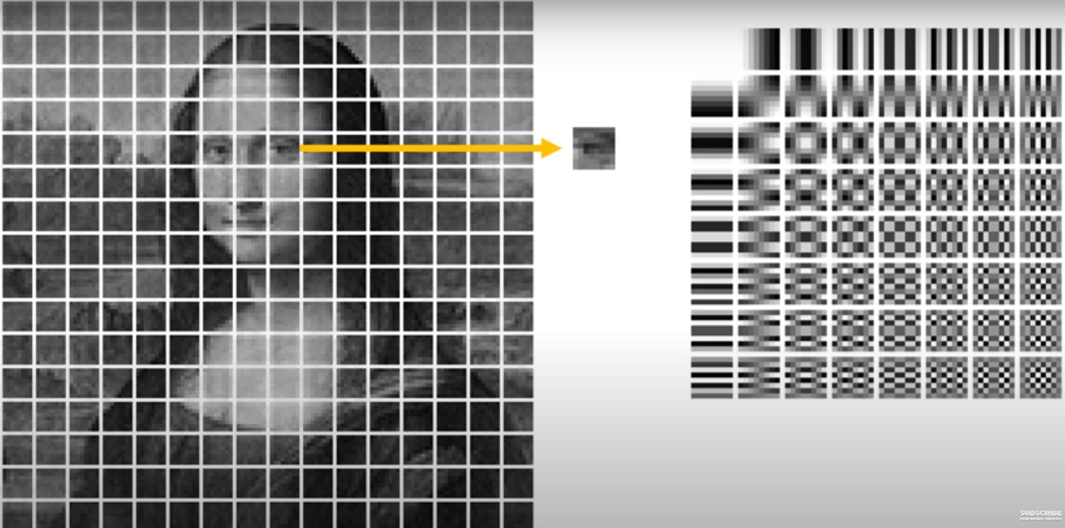

LHS block represent the brightness level and RHS block represent the presence of particle of the frequency component. Discrete Cosine Transform.

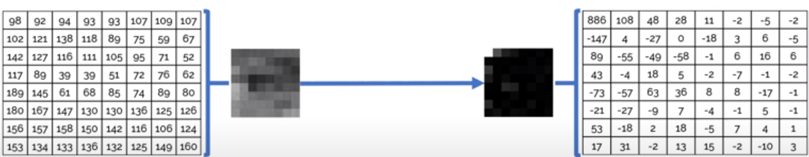

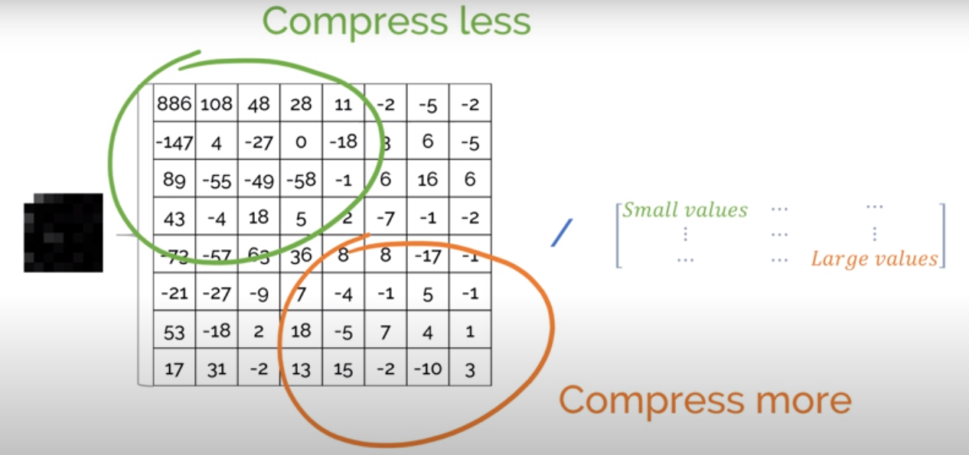

By using larger divisor this above block data can be reduce to almost zero, this results in higher compression rate. But it lowers the image quality. This division method known as contestation. After Contestation we get data like below:

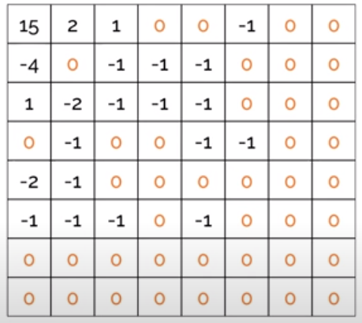

If we rearrange this information from top left to bottom right then we can group the zero’s together.

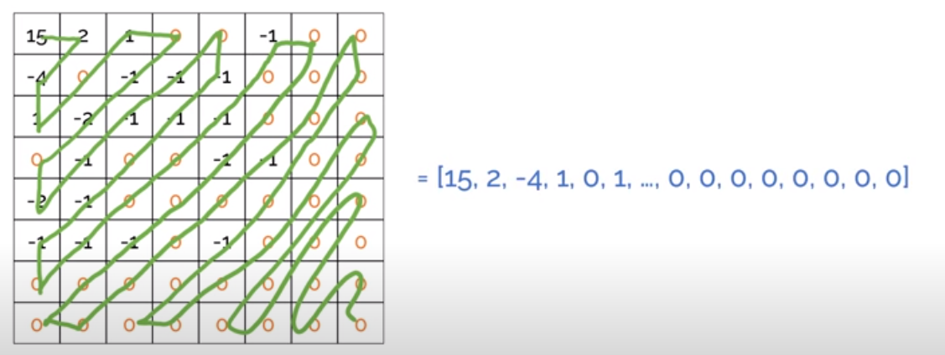

Instead of storing zero separately we can use tuple like below. This method is know as **Run-link encoding**, this use in many other algorithms. Then the remain value can get average value so that we can reduce that data as well, this method known as **Huffman (entropy) encoding**. This both encoding (compression) done on various data like image, audio, documents, etc.

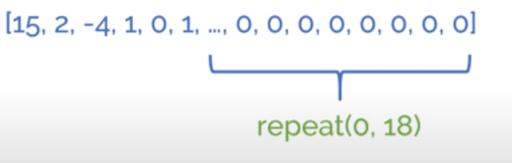

For decode the image all below steps have to follow:

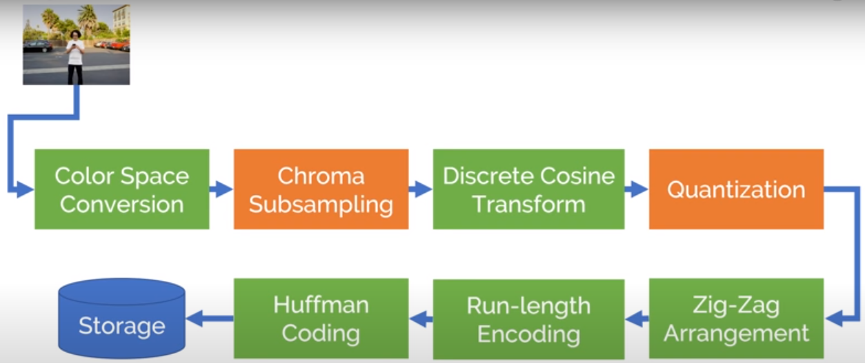

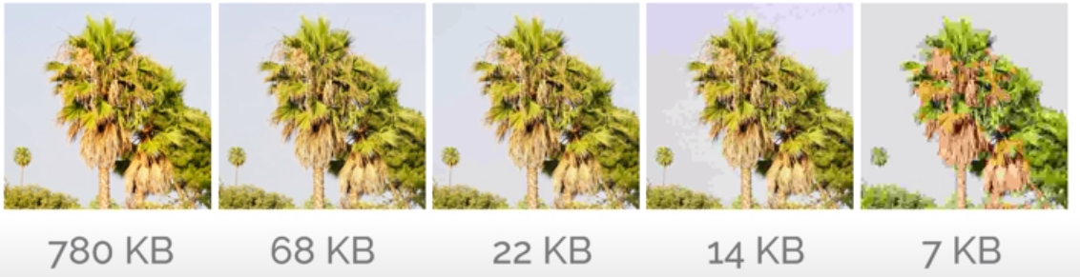

# References

Video Introduction

<https://www.javatpoint.com/what-is-video/>

<https://www.techtarget.com/whatis/definition/progressive-scan/>

Analog and Digital video

<https://prezi.com/6flndlf-ymhf/the-difference-between-analog-video-and-digital-video/>

<https://www.youtube.com/watch?v=iETz3glO4XE/>

<https://www.youtube.com/watch?v=ujQI65OU5HM/>

Display resolutions:

<https://etc.usf.edu/techease/win/images/what-is-bit-depth/>

<https://www.youtube.com/watch?v=ogYACMsBg5w/>

<https://support.humblebundle.com/hc/article_attachments/360008054853/Resolutions.png/>

FPS:

<https://www.youtube.com/watch?v=-RHGGVMkNwc/>

<https://www.youtube.com/watch?v=_XzGhc9mPVk&t/>

GOP:

<https://www.veneratech.com/understanding-gop-what-is-group-of-pictures-and-why-is-it-important/>

Chroma subsampling:

<https://www.youtube.com/watch?v=Vt1Q6McYmOc/>

<https://www.youtube.com/watch?v=wUyqathWeV0/>

<https://www.youtube.com/watch?v=yinOtVTWJFY/>

<https://www.youtube.com/watch?v=a7ePgZ0p2xM/>

<https://www.youtube.com/watch?v=DakHAB5PYWA/>

Video streaming:

<https://www.youtube.com/watch?v=Lpca3EGLYJI/>

Video Encoding:

<https://www.youtube.com/watch?v=JTC4ps8HFG8/>

<https://www.youtube.com/watch?v=GQucxiTp3nQ/>

Video Decoding: